Railway Reservation System
SR | USER Requirements | GPT Results | VeriGen Results
 | The Customer clicks the log-in button on the Home Page. | 2 The system shall provide the ability to display a "Log In" button on the Home Page. | 1. The system shall provide customer with the ability to click the login button on the home page.
 | The system displays the log-in page. | 3 The system shall provide the ability to display a "Log In" page when the "Log In" button is clicked. | 2. The system shall be able to display the login page.
 | The customer enters his login Id with password. | 4 The system shall provide the ability to enter a login ID on the "Log In" page. | 3. The system shall provide customer with the ability to enter his login i d with password.
 | The customer clicks on the confirm button. | 6 The system shall provide the ability to click a "Confirm" button after entering login credentials. | 4. The system shall provide customer with the ability to click on the confirm button.
 | The system checks that all of the required information was entered. | 7 The system shall be able to check if both login ID and password fields have been entered when "Confirm" is clicked. | 5. The system shall be able to check that all of the required information entered.
 | If the entered information is wrong then system asks customer to reenter the details. | 8 If any required login information is missing, then the system shall be able to display an error message indicating missing fields. | 6. If the entered information is wrong then the system shall be able to ask customer to reenter details.
 | The system validates the entered information against the tables stored in the database. | 10 The system shall be able to validate the entered login credentials against the user database. | 7. The system shall be able to validate the entered information against the tables stored in the database.
 | The admin clicks the log-in button on the Home Page. | Missing | 8. The system shall provide admin with the ability to click the login button on the home page.
 | The system displays the log-in page. | Missing | 9. The system shall be able to display the login page.
 | The admin enters his login Id with password. | Missing | 10. The system shall provide admin with the ability to enter his login i d with password.
 | The admin clicks on the confirm button. | Missing | 11. The system shall provide admin with the ability to click on the confirm button.
 | The system checks that all of the required information was entered. | Missing | 12. The system shall be able to check that all of the required information entered.
 | If the entered information is wrong then system asks Admin to reenter the details. | Missing | 13. If the entered information is wrong then the system shall be able to ask admin to reenter details.
 | The system validates the entered information against the tables stored in the database. | Missing | 14. The system shall be able to validate the entered information against the tables stored in the database.
 | The customer already has navigated to the main options screen. | 14 The system shall provide the ability to navigate to the main options screen after successful login. | 15. The system shall provide customer with the ability to already navigate to the main options screen.
 | The customer enters the details of source station, destination station, date to get the best possible trains. | 15 The system shall provide the ability to enter a source station on the main options screen. | 16. The system shall provide customer with the ability to enter the details of source station , destination station , date to get the best possible trains.
 | The customer also enters the type of train he wants to book. | 18 The system shall provide the ability to select a type of train to book on the main options screen. | 17. The system shall provide customer with the ability to also enter the type of train train wants to book.
 | Customer enters all the information. | Missing | 18. The system shall provide customer with the ability to enter all the information.
 | The customer can use help facility to know how to fill the information, HelpFacility usecase is carried out. | Missing | 19. The system shall provide customer with the ability to use help facility to know how to fill the information , helpfacility usecase carried out.
 | He clicks the "Search" button. | Missing | 20. The system shall be able to clicks search button.
 | If all the required information is not entered by the customer then the system highlights the blank fields to be entered. | 21 If any required train search information is missing, then the system shall be able to highlight the blank fields. | 21. If all the required information is not entered by the customer then the system shall be able to highlight blank fields to entered.
 | After searching, the System displays a list of all the trains that matches the customer’s input, each train in the list has an associated price. | 22 If all required train search information is entered, then the system shall be able to search for trains matching the input criteria. | 22. The system shall be able to display a list of all the trains that matches the customers input , each in the list has an associated price.
 | Customer selects the "Purchase Ticket" link from the list of options. | 25 The system shall provide the ability to select a "Purchase Ticket" link from the list of options. | 23. The system shall provide customer with the ability to select the purchase ticket link from the list of options.
 | The system displays a screen with an input field for a reservation number. | 26 The system shall be able to display a screen with an input field for a reservation number when "Purchase Ticket" is selected. | 24. The system shall be able to display a screen with an input field for a reservation number.
 | The customer enters a reservation number. | 27 The system shall provide the ability to enter a reservation number on the purchase ticket screen. | 25. The system shall provide customer with the ability to enter a reservation number.
 | He clicks the "Submit" button. | 28 The system shall provide the ability to click a "Submit" button after entering a reservation number. | 26. The system shall be able to clicksThe system shall be able to display the details of the reservation.
 | System displays the details of the reservation and the customer selects the "Purchase Ticket" option. | 32 The system shall provide the ability to select a "Purchase Ticket" option after reservation details are displayed. | 27. The system shall provide customer with the ability to select the purchase ticket option.
 | System displays a screen with input fields for: a credit card number, cardholder name, credit card expiration date. | 33 The system shall be able to display a screen with input fields for credit card number, cardholder name, and credit card expiration date. | 28. The system shall be able to display a screen with input fields for a credit card number , cardholder name , credit card expiration date.
 | Customer enters the details for the credit card number, the cardholder name , the credit card expiration date and he clicks the "Submit" button. | 34 The system shall provide the ability to enter a credit card number for payment. | 29. The system shall provide customer with the ability to enter the details for the credit card number , the cardholder name , the credit card expiration date and train clicks the submit button.
 | If customer is stuck in the process then he can use help facility to know how to fill the information, HelpFacility usecase is carried out. | 48. The system shall provide the ability to access a help facility from any screen. | 30. If customer is stuck in the process then the system shall be able to use he help facility to know how to fill information , helpfacility usecase is carried out.
 | System displays the success message. | Missing | 31. The system shall be able to display the success message.
 | A reservation has already been made and customer must have successfully navigated to the main options screen. | Missing | 32. The system shall provide customer with the ability to successfully navigate to the main options screen.
 | Customer Selects the "Cancel Reservation" option. | 55 The system shall provide the ability to select a "Cancel Reservation" option from the main options screen. | 33. The system shall provide customer with the ability to select the cancel reservation option.
 | System displays a screen with an input field for a reservation number and Customer enters a reservation number and he clicks the "Submit" button. | 56 The system shall be able to display a screen with an input field for a reservation number when "Cancel Reservation" is selected. | 34. The system shall be able to display a screen with an input field for a reservation number and customer enters a reservation number and he clicks the submit button.
 | The customer can use help facility, HelpFacility use case is carried out. | Missing | 35. The system shall provide customer with the ability to use help facility , helpfacility use case carried out.
 | System displays the details of the reservation. | 61 If the reservation number is valid, then the system shall be able to display the details of the reservation. | 36. The system shall be able to display the details of the reservation.
 | Customer Selects the "Process Cancellation" option and then system displays the main options screen again. | 62 The system shall provide the ability to select a "Process Cancellation" option after reservation details are displayed. | 37. The system shall provide customer with the ability to select the process cancellation option and then system displays the main options screen again.
 | The website provides instructions to the customers on how to book tickets, search trains, cancel reservation. | 52 The system shall be able to provide instructions on how to book tickets | 38. The system shall provide website with the ability to provide instructions to the customers on how to book tickets , search trains , cancel reservation.
 | The customer clicks on help facility. | Missing | 39. The system shall provide customer with the ability to click on help facility.
 | The system displays a list of facilities. | Missing | 40. The system shall be able to display a list of facilities.
 | The customer clicks on the type of healp required. | Missing | 41. The system shall provide customer with the ability to click on the type of healp required.
 | The system shows the instructions. | Missing | 42. The system shall be able to show the instructions.
 | The admin manages the train. | 67 The system shall provide the ability to manage trains from the main options screen. | 43. The system shall provide admin with the ability to manage the train.
 | The system asks Admin whether he wants to Add Train or Remove train. | 68 The system shall be able to ask whether to add or remove a train when managing trains. | 44. The system shall be able to ask admin whether he wants to add train or remove train.
 | The Admin selects to add train, AddTrain usecase is carried out. | 69. The system shall provide the ability to select "Add Train" when managing trains. | 45. The system shall provide train with the ability to carriedIf admin selects to remove train, then the system shall be able to carry removetrain usecase out.
 | If Admin selects to remove train, then RemoveTrain usecase is carried out. | Missing | Missing
 | The Admin already has navigated to the main options screen. | Missing | 46. The system shall provide admin with the ability to already navigate to the main options screen.
 | The system validates the log in information. | Missing | 47. The system shall be able to validate the log in information.
 | The admin selects on adding the trains. | Missing | 48. The system shall be able to adding admin selects trains.
 | The system asks admin to fill all the required information for adding a train in the database. | 71 The system shall provide the ability to enter all required information for adding a train. | 49. The system shall be able to ask admin to fill all the required information for adding a train in the database.
 | The admin fills the information. | Missing | 50. The system shall provide admin with the ability to fill the information.
 | The system displays a success message on the screen. | 76 If the train is added successfully, then the system shall be able to display a success message. | 51. The system shall be able to display a success message on the screen.
 | If all the required information is not filled by Admin then the system shows an error message. | 74 If any required train information is missing, then the system shall be able to display an error message indicating missing fields. | 52. If all the required information is not filled by admin then the system shall be able to show an error message.
 | The Admin already has navigated to the main options screen. | Missing | 53. The system shall provide admin with the ability to already navigate to the main options screen.
 | The system validates the log in information. | Missing | 54. The system shall be able to validate the log in information.
 | The admin selects on remove trains. | 77 The system shall provide the ability to select "Remove Train" when managing trains. | 55. The system shall be able to admin selects remove trains.
 | The system asks admin to fill all the required information for removing a train in the database. | Missing | 56. The system shall be able to ask admin to fill all the required information for removing a train in the database.
 | The admin fills all the required information. | 79 The system shall provide the ability to enter all required information for removing a train. | 57. The system shall provide admin with the ability to fill all the required information.
 | The system displays a success message on the screen. | 84 If the train is removed successfully, then the system shall be able to display a success message. | 58. The system shall be able to display a success message on the screen.
 | If all the required information is not filled by Admin then the system shows an error message. | 82 If any required train removal information is missing, then the system shall be able to display an error message indicating missing fields. | 59. If all the required information is not filled by admin then the system shall be able to show an error message.
 |  | 5 The system shall provide the ability to enter a password on the "Log In" page.
 |  | 9 If any required login information is missing, then the system shall be able to highlight the blank fields.
 |  | 11 If the entered login credentials are incorrect, then the system shall be able to display an error message requesting re-entry of details.
 |  | 12 If the entered login credentials are incorrect, then the system shall be able to clear the password field for security.
 |  | 13 If the entered login credentials are correct, then the system shall be able to grant access to the main options screen.
 |  | 16 The system shall provide the ability to enter a destination station on the main options screen.
 |  | 17 The system shall provide the ability to enter a travel date on the main options screen.
 |  | 19 The system shall provide the ability to click a "Search" button after entering train search criteria.
 |  | 20 The system shall be able to check if all required train search information has been entered when "Search" is clicked.
 |  | 23 The system shall be able to display a list of trains matching the search criteria.
 |  | 24 The system shall be able to display the associated price for each train in the search results.
 |  | 29 The system shall be able to validate the entered reservation number against the reservation database.
 |  | 30 If the reservation number is invalid, then the system shall be able to display an error message indicating invalid reservation.
 |  | 31 If the reservation number is valid, then the system shall be able to display the details of the reservation.
 |  | 35 The system shall provide the ability to enter a cardholder name for payment.
 |  | 36 The system shall provide the ability to enter a credit card expiration date for payment.
 |  | 37 The system shall provide the ability to click a "Submit" button after entering payment details.
 |  | 38 The system shall be able to check if all required payment information has been entered when "Submit" is clicked.
 |  | 39 If any required payment information is missing, then the system shall be able to display an error message indicating missing fields.
 |  | 40 If any required payment information is missing, then the system shall be able to highlight the blank fields.
 |  | 41 The system shall be able to validate the credit card number format.
 |  | 42 If the credit card number format is invalid, then the system shall be able to display an error message indicating invalid card number.
 |  | 43 The system shall be able to validate the credit card expiration date format.
 |  | 44 If the credit card expiration date format is invalid, then the system shall be able to display an error message indicating invalid expiration date.
 |  | 45 If all payment information is valid, then the system shall be able to process the payment.
 |  | 46 If the payment is successful, then the system shall be able to display a success message.
 |  | 47 If the payment fails, then the system shall be able to display an error message indicating payment failure.
 |  | 49 The system shall be able to display a list of help topics when the help facility is accessed.
 |  | 50 The system shall provide the ability to select a type of help required from the help topics list.
 |  | 51 The system shall be able to display instructions for the selected help topic.
 |  | 53 The system shall be able to provide instructions on how to search for trains.
 |  | 54 The system shall be able to provide instructions on how to cancel a reservation.
 |  | 57 The system shall provide the ability to enter a reservation number on the cancel reservation screen.
 |  | 58 The system shall provide the ability to click a "Submit" button after entering a reservation number for cancellation.
 |  | 59 The system shall be able to validate the entered reservation number for cancellation.
 |  | 60 If the reservation number is invalid, then the system shall be able to display an error message indicating invalid reservation.
 |  | 63 The system shall be able to process the cancellation of the reservation.
 |  | 64 If the cancellation is successful, then the system shall be able to display a success message.
 |  | 65 If the cancellation fails, then the system shall be able to display an error message indicating cancellation failure.
 |  | 66 After processing a cancellation, the system shall be able to display the main options screen again.
 |  | 70 If "Add Train" is selected, then the system shall be able to display input fields for all required train information.
 |  | 72 The system shall provide the ability to click a "Submit" button after entering train information.
 |  | 73 The system shall be able to check if all required train information has been entered when adding a train.
 |  | 75 If all required train information is entered, then the system shall be able to add the train to the database.
 |  | 78 If "Remove Train" is selected, then the system shall be able to display input fields for all required information to remove a train.
 |  | 80 The system shall provide the ability to click a "Submit" button after entering train removal information.
 |  | 81 The system shall be able to check if all required train removal information has been entered.
 |  | 83 If all required train removal information is entered, then the system shall be able to remove the train from the database.
 |  | 85. The system shall be able to validate admin login information before allowing access to train management functions.
 |  | 86. The system shall be able to log all successful and failed login attempts for audit purposes.
 |  | 87. The system shall be able to log all train addition and removal actions for audit purposes.
 |  | 88. The system shall be able to timeout the session after a period of inactivity.
 |  | 89. If the session times out, then the system shall be able to log the user out and display a session timeout message.
 |  | 90. The system shall be able to mask the password input field to prevent display of typed characters.
 |  | 91. The system shall be able to provide feedback to the user after each action, indicating success or failure.
 |  | 92. The system shall be able to prevent SQL injection and other common security vulnerabilities in all input fields.
 |  | 93. The system shall be able to handle concurrent logins by different users.
 |  | 94. The system shall be able to handle simultaneous train search requests.
 |  | 95. The system shall be able to handle simultaneous ticket purchase requests.
 |  | 96. The system shall be able to handle simultaneous reservation cancellation requests.
 |  | 97. The system shall be able to display appropriate error messages for system errors or unexpected failures.
 |  | 98. The system shall be able to provide a "Back" button on each screen to allow users to return to the previous screen.
 |  | 99. The system shall be able to clear sensitive input fields after submission or error.
 |  | 100. The system shall be able to confirm with the user before finalizing actions such as ticket purchase or reservation cancellation.
 |  | 101. The system shall be able to provide context-sensitive help based on the current screen or action.

Class Diagram (GPT)
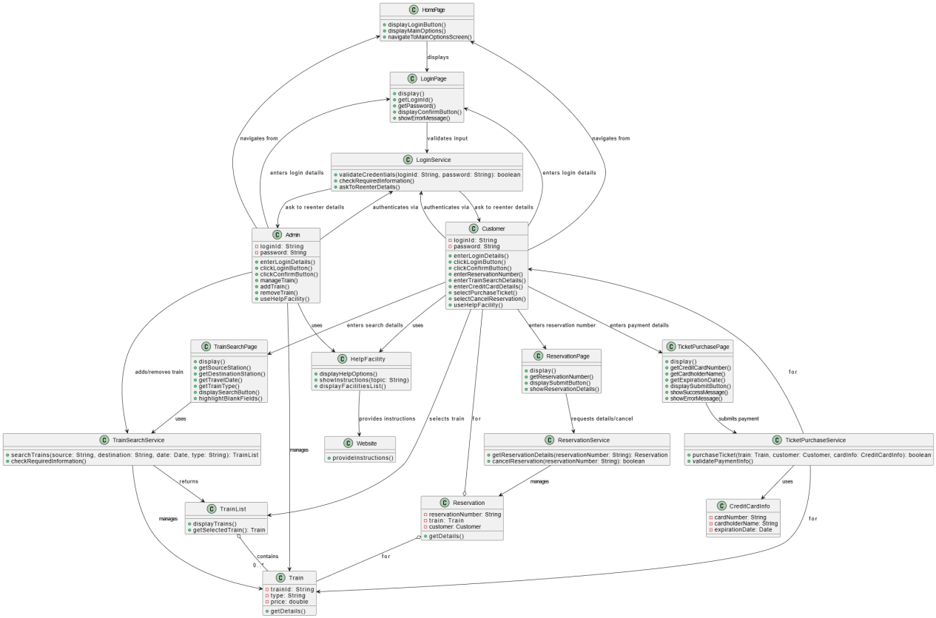
Class Diagram (VeriGen)

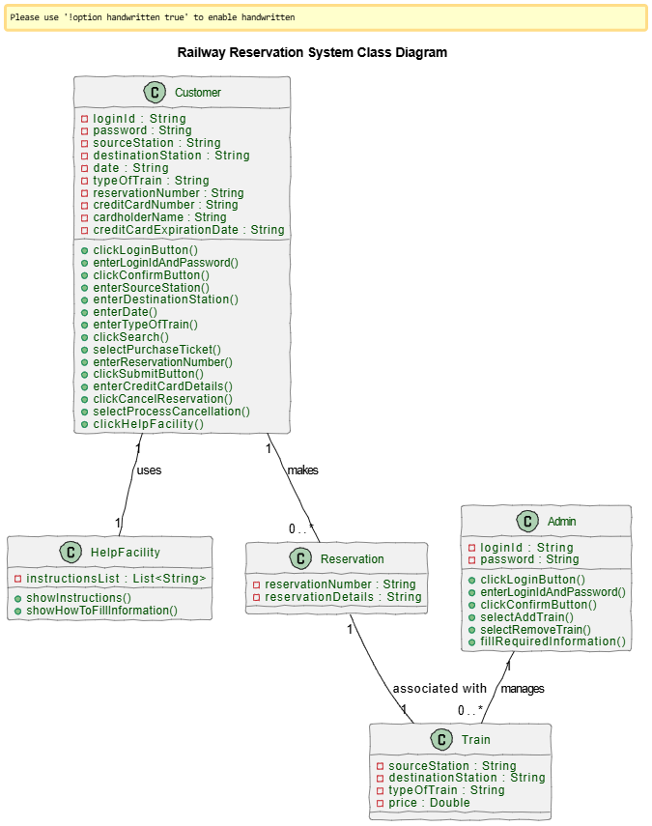

Sequence Diagram (VeriGen)
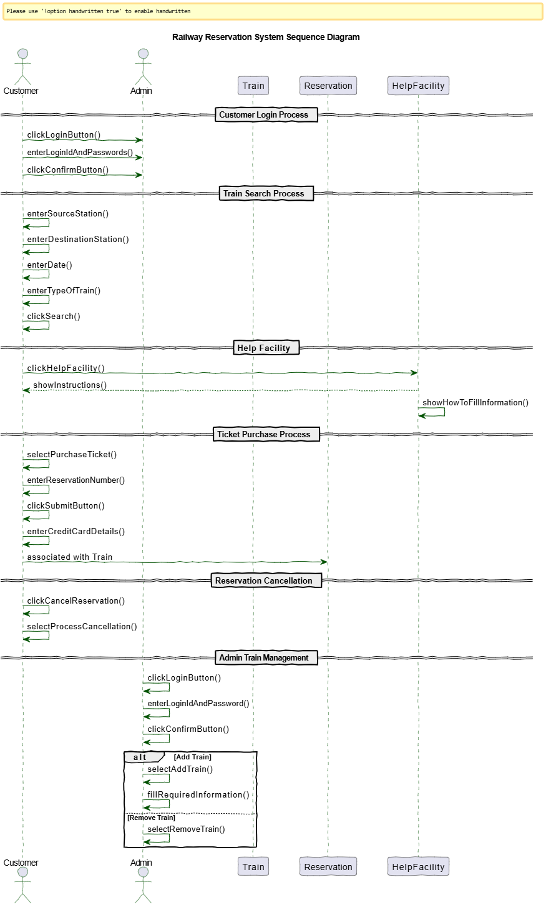

Sequence Diagram (GPT)
